Silhouette metric for img016001.jpg is: 0.8162798430268816

Davies Bouldin metric for img016001.jpg is: 0.11080845029861226

Calinski Harabasz metric for img016001.jpg is: 245575.6475562477

ID 0: (450, 1056)

ID 1: (995, 648)

ID 2: (1603, 293)

ID 3: (1825, 641)

ID 4: (1691, 701)

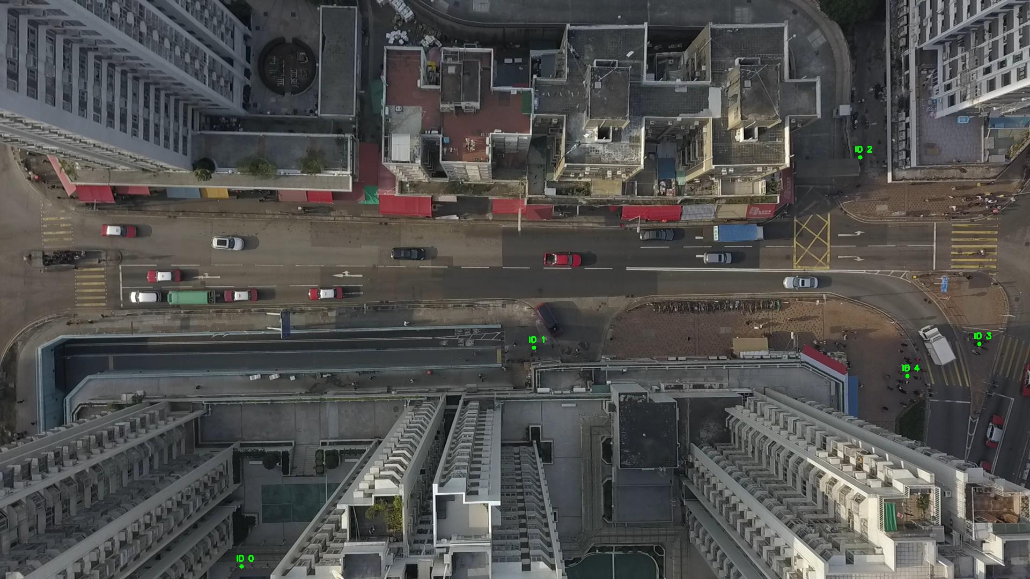

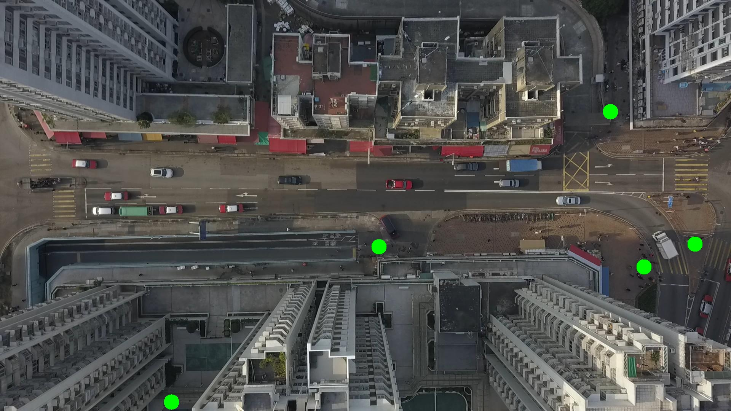

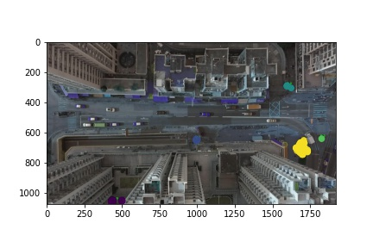

Silhouette metric for img016002.jpg is: 0.8014797205339047

Davies Bouldin metric for img016002.jpg is: 0.10639705300990657

Calinski Harabasz metric for img016002.jpg is: 210722.7678846586

ID 0: (442, 1057)

ID 1: (996, 648)

ID 2: (1623, 304)

ID 3: (1825, 641)

ID 4: (1690, 702)

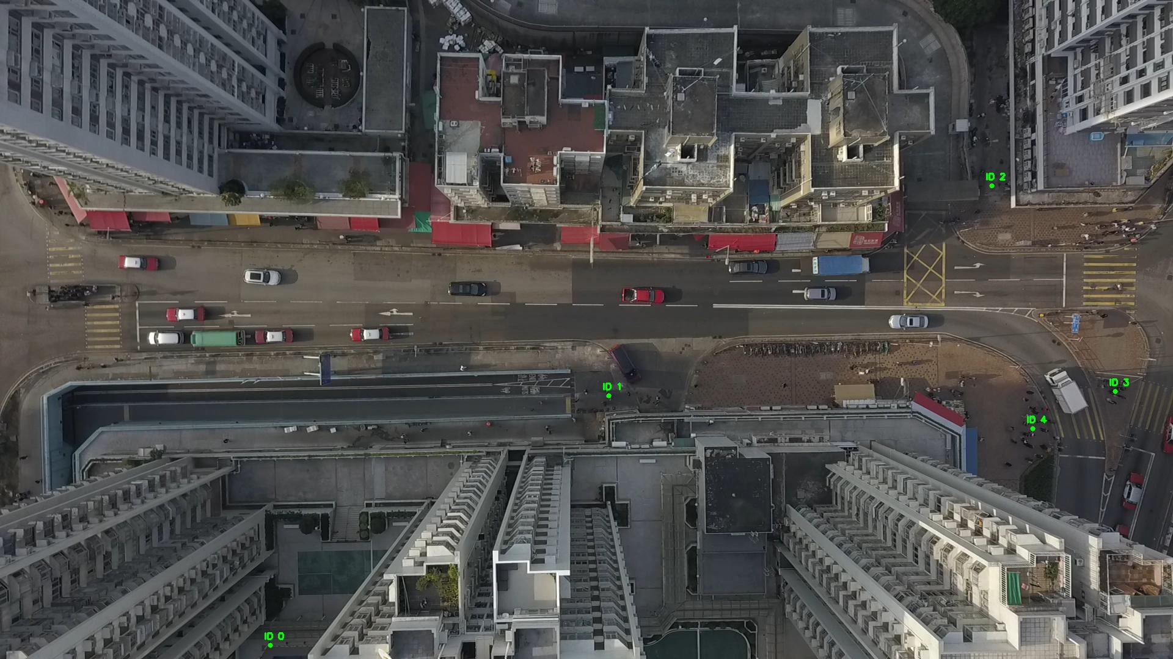

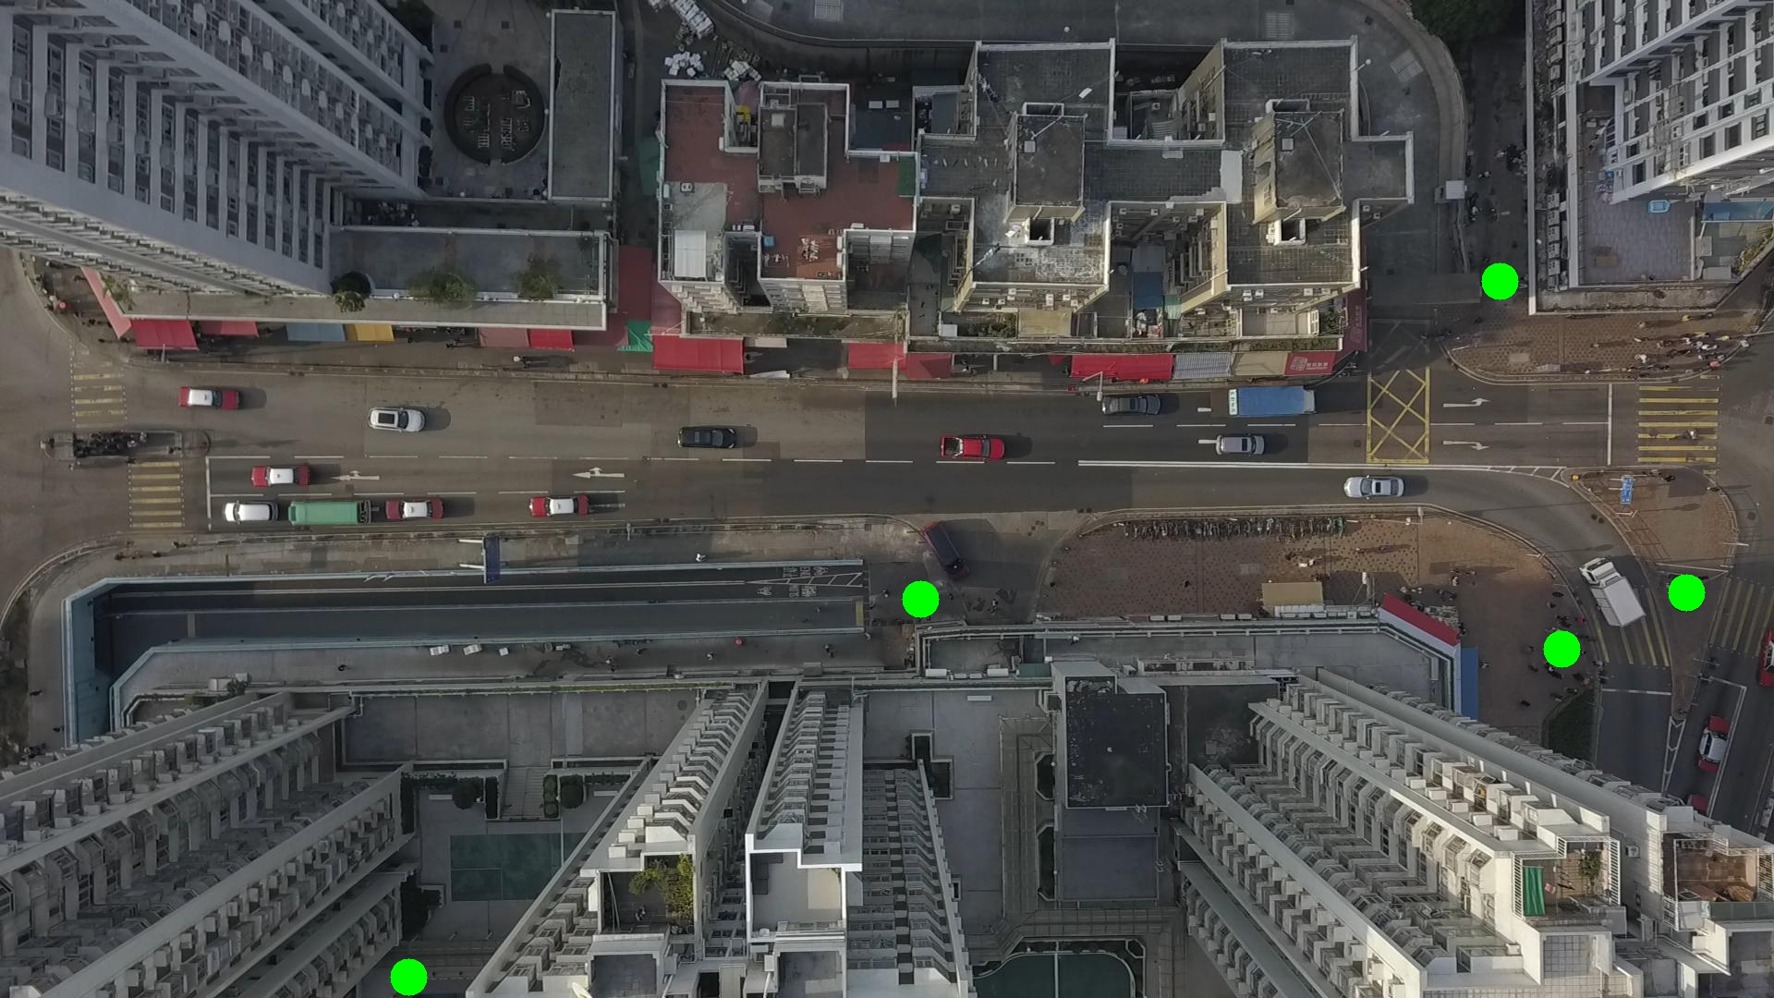

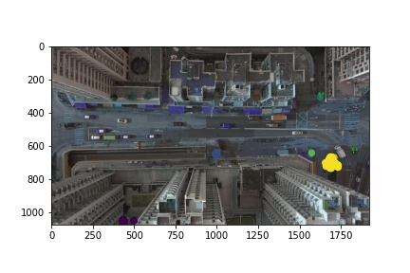

Silhouette metric for img016003.jpg is: 0.7787407602490647

Davies Bouldin metric for img016003.jpg is: 0.11491681985779297

Calinski Harabasz metric for img016003.jpg is: 185387.6886159519

ID 0: (448, 1059)

ID 1: (994, 651)

ID 2: (1623, 304)

ID 3: (1831, 642)

ID 4: (1686, 699)

ID 5: (100, 347)

ID 6: (87, 486)

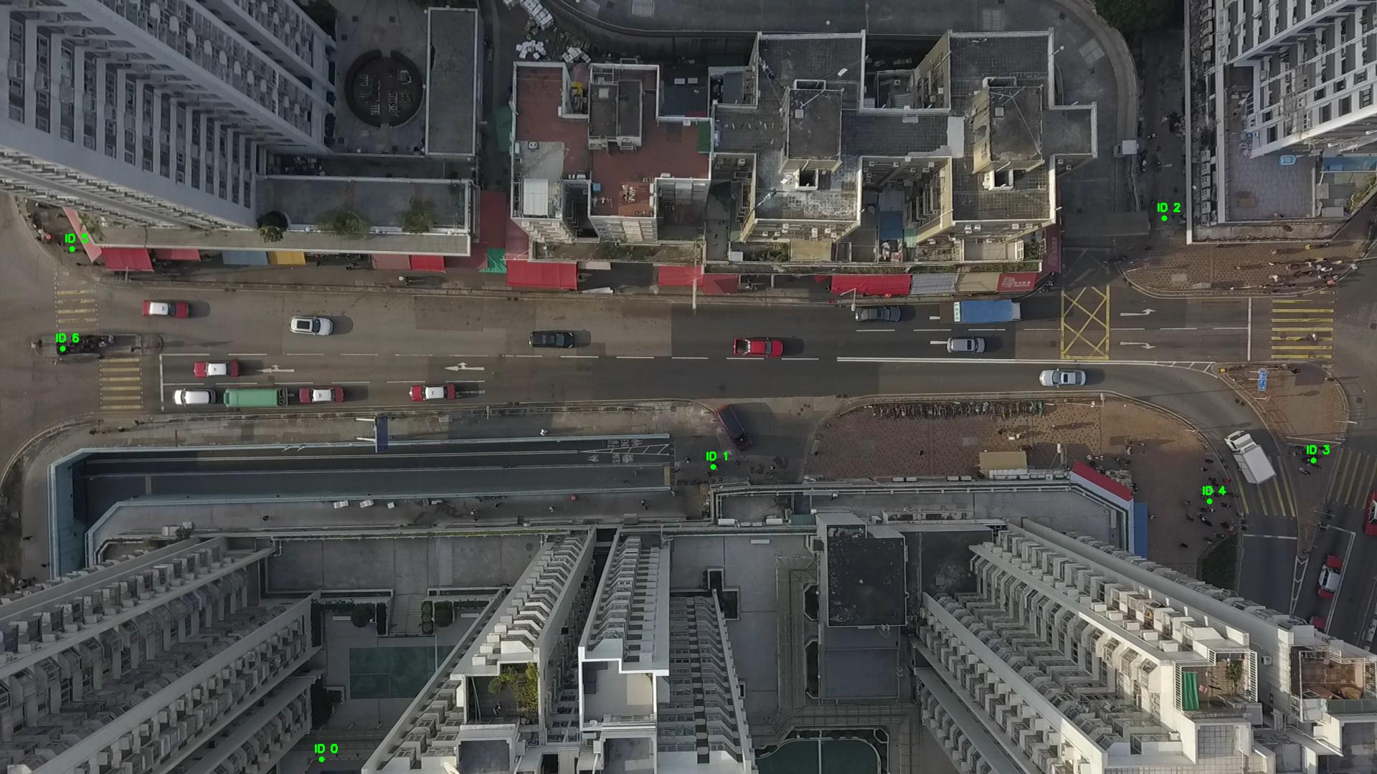

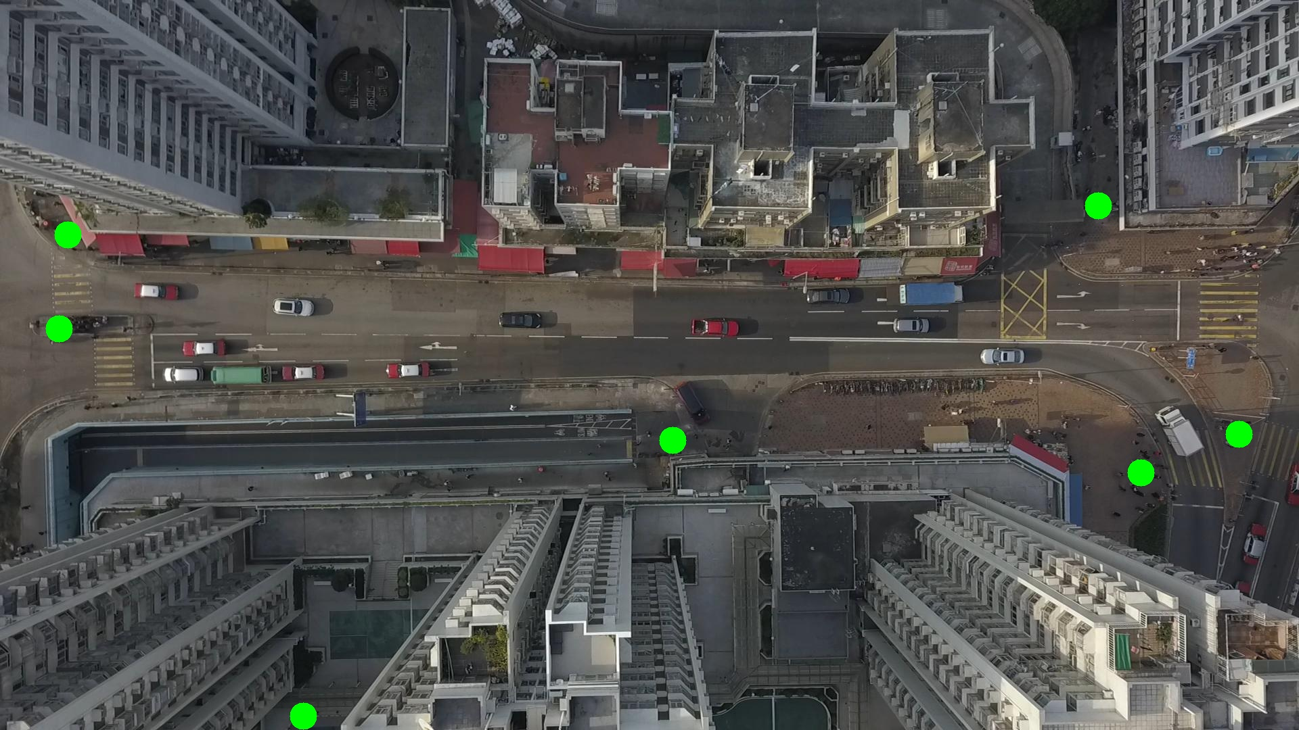

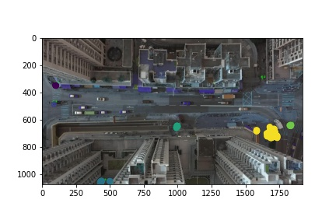

Silhouette metric for img016004.jpg is: 0.8065247568146118

Davies Bouldin metric for img016004.jpg is: 0.13159926308944253

Calinski Harabasz metric for img016004.jpg is: 191113.14059441065

ID 0: (447, 1058)

ID 1: (993, 651)

ID 2: (1599, 287)

ID 3: (1830, 641)

ID 4: (1686, 701)

ID 5: (100, 347)

ID 6: (87, 486)

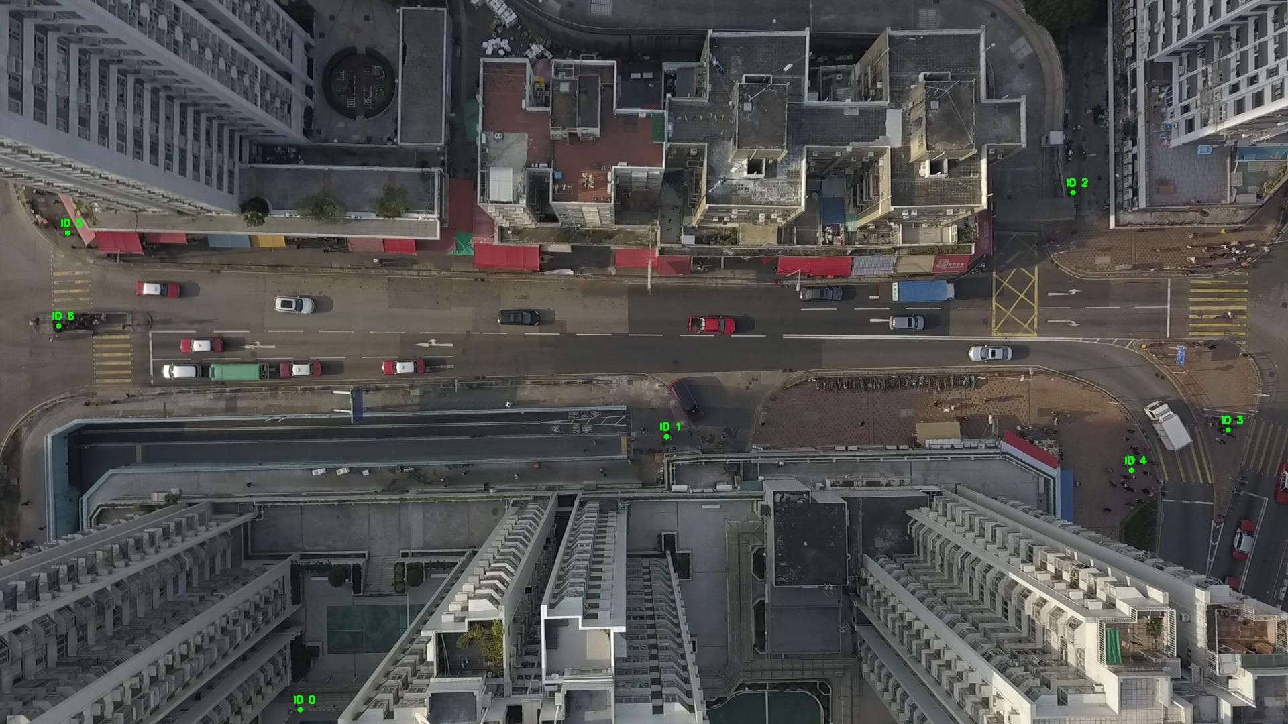

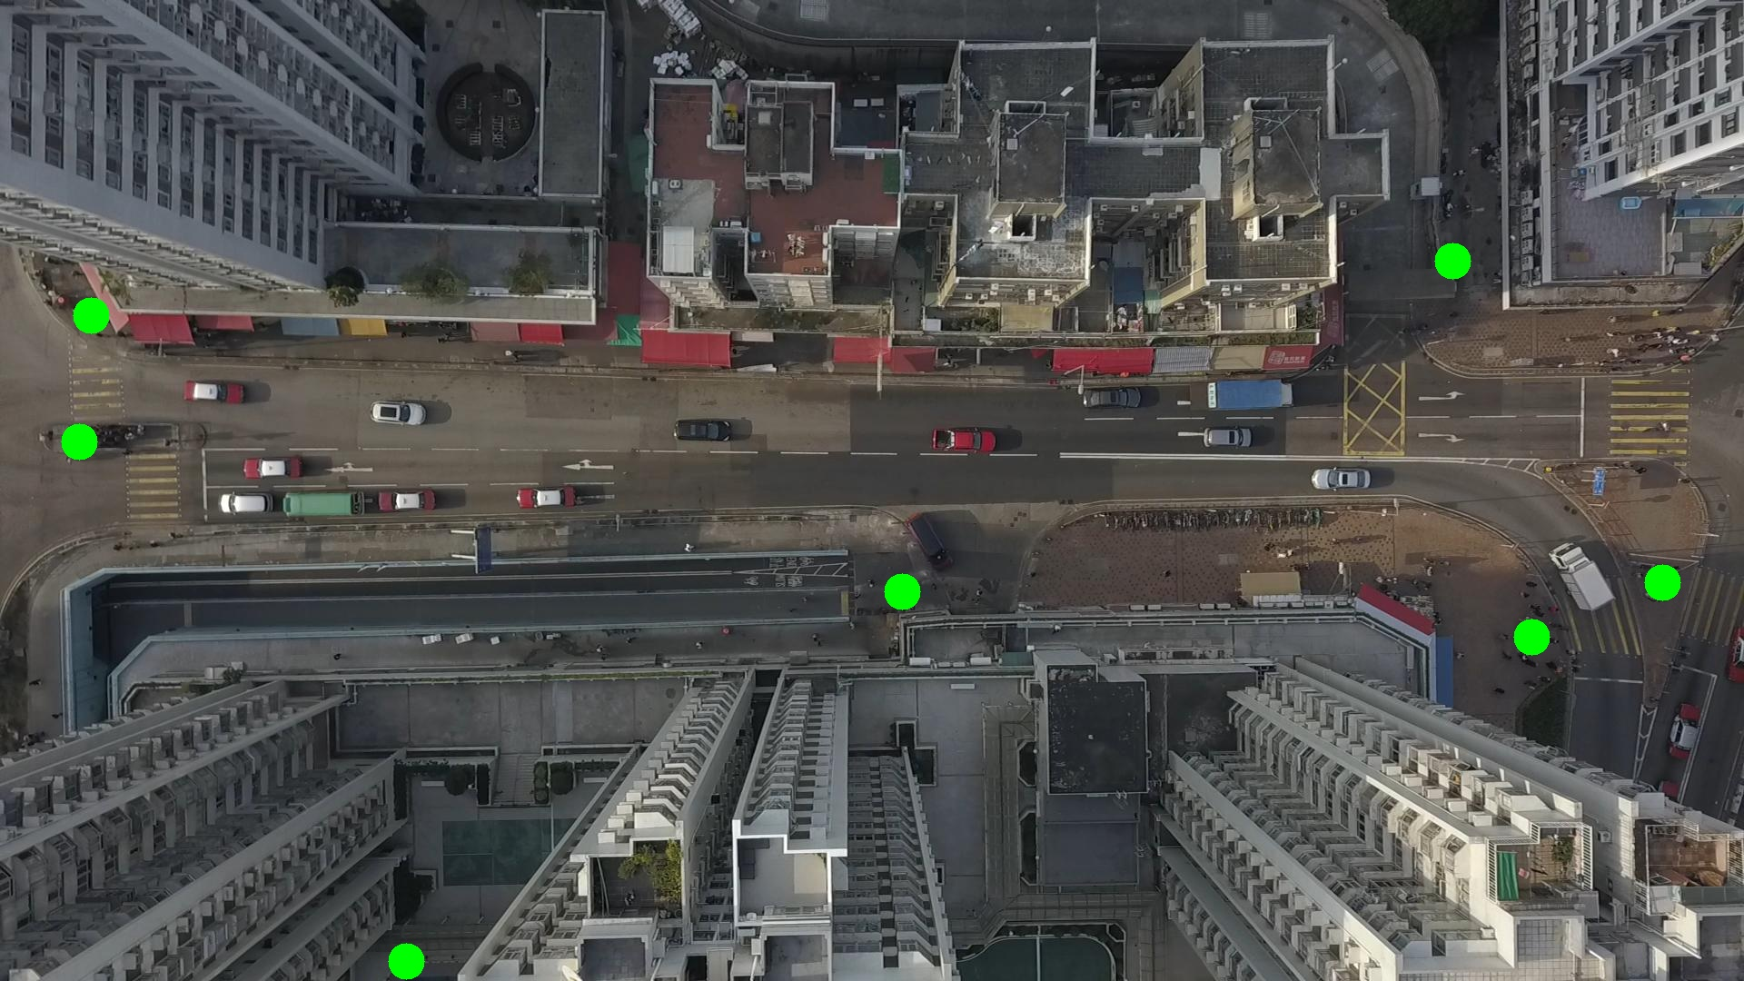

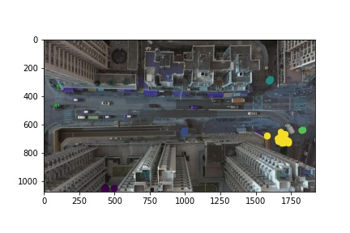

Silhouette metric for img016005.jpg is: 0.8079872465079725

Davies Bouldin metric for img016005.jpg is: 0.13992014733956518

Calinski Harabasz metric for img016005.jpg is: 298988.6684103254

ID 0: (439, 1061)

ID 1: (994, 650)

ID 2: (1599, 287)

ID 3: (1829, 642)

ID 4: (1690, 703)

ID 5: (100, 347)

ID 6: (305, 1068)

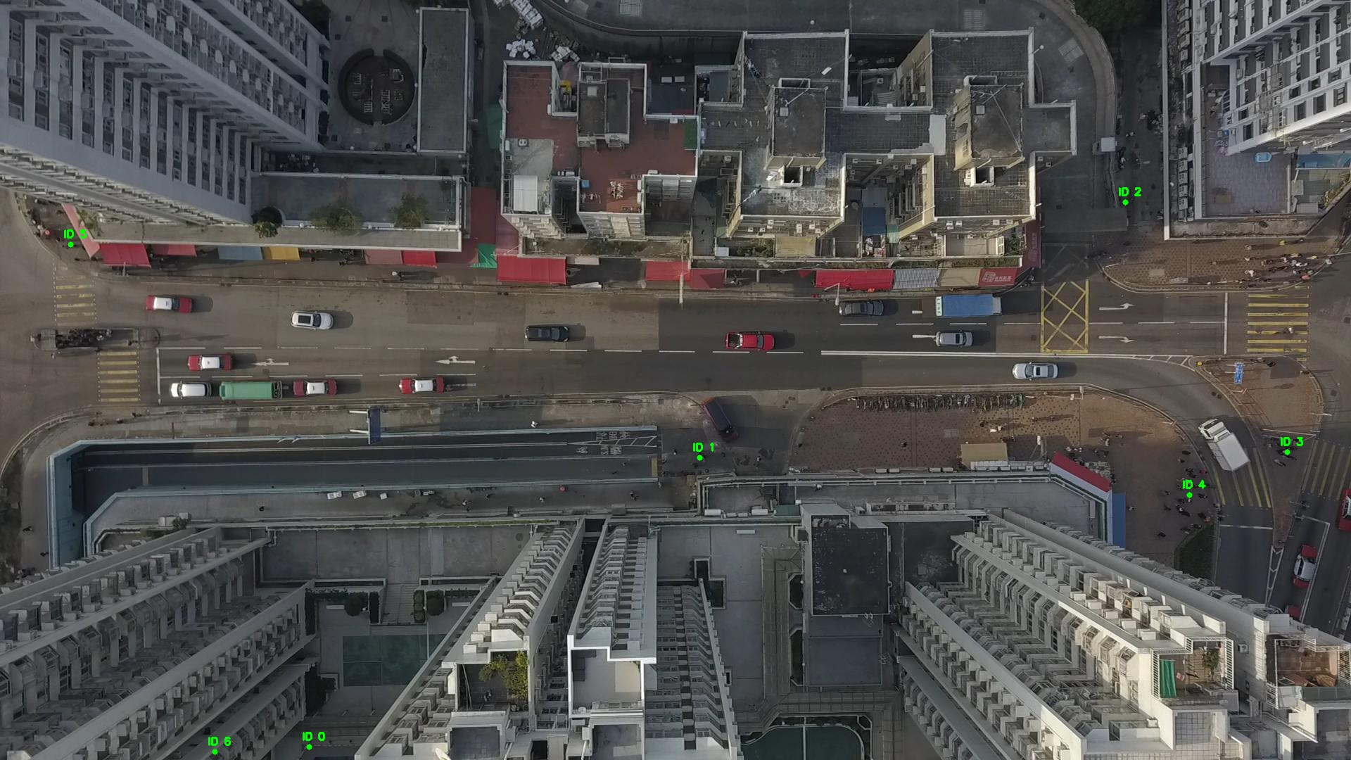

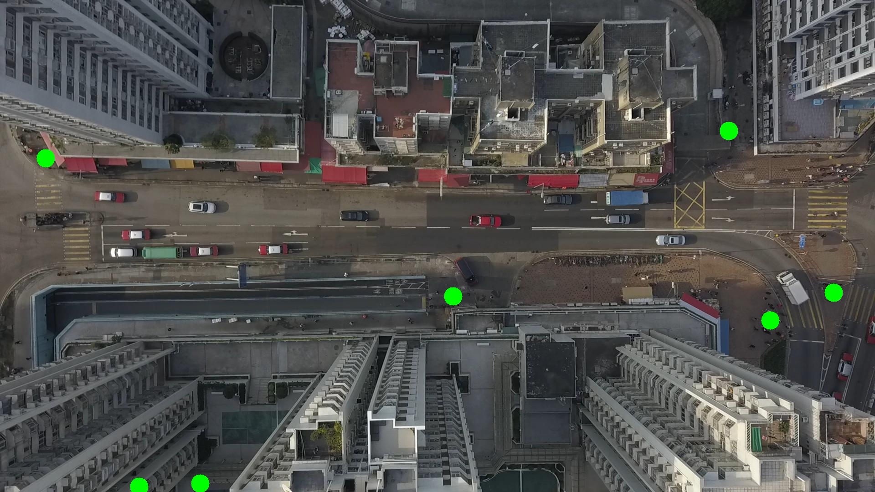

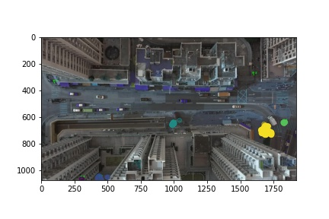

Silhouette metric for img016006.jpg is: 0.8106496135519073

Davies Bouldin metric for img016006.jpg is: 0.17113769495682082

Calinski Harabasz metric for img016006.jpg is: 507606.23960606643

ID 0: (433, 1061)

ID 1: (994, 650)

ID 2: (1599, 287)

ID 3: (1831, 642)

ID 4: (1688, 700)

ID 5: (100, 347)

ID 6: (310, 1065)

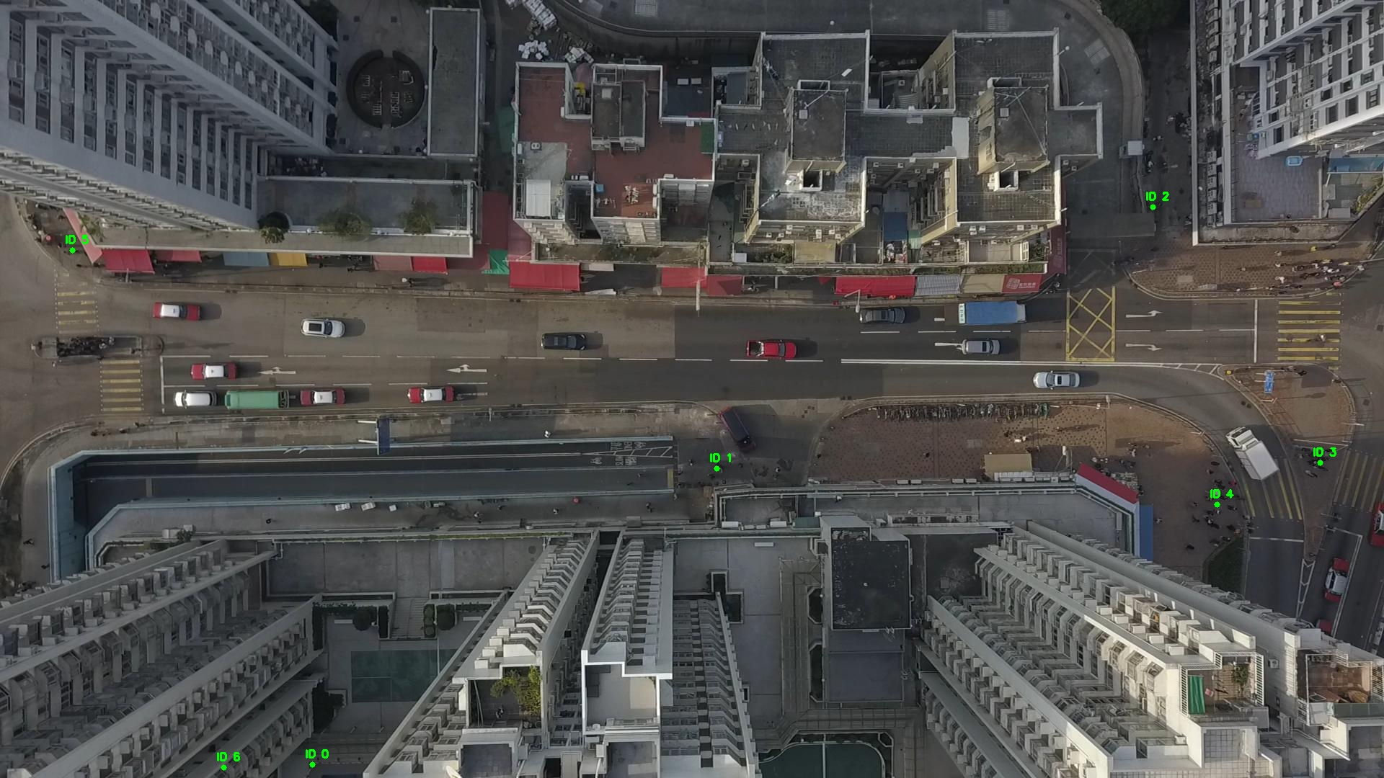

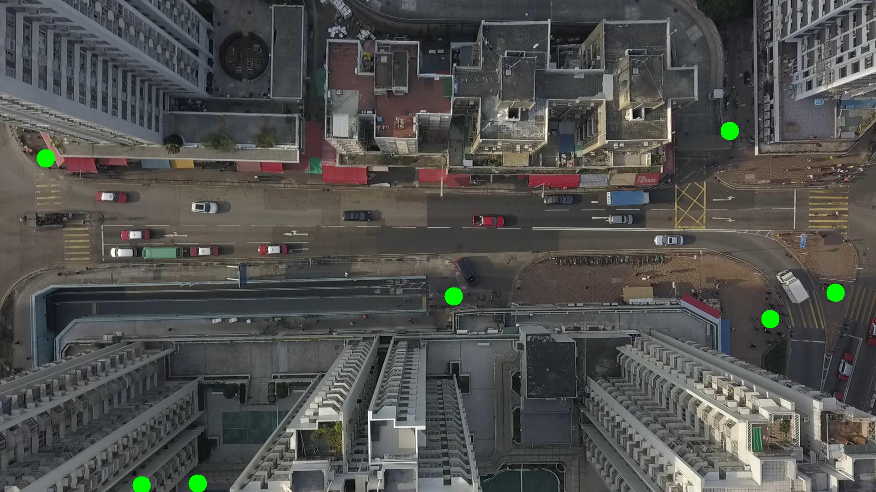

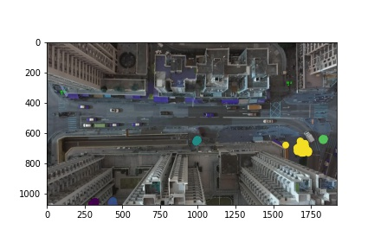

Silhouette metric for img016007.jpg is: 0.8025161900070145

Davies Bouldin metric for img016007.jpg is: 0.1768785013676588

Calinski Harabasz metric for img016007.jpg is: 435262.2017370945

ID 0: (436, 1060)

ID 1: (995, 649)

ID 2: (1569, 636)

ID 3: (1830, 642)

ID 4: (1689, 700)

ID 5: (100, 347)

ID 6: (310, 1065)

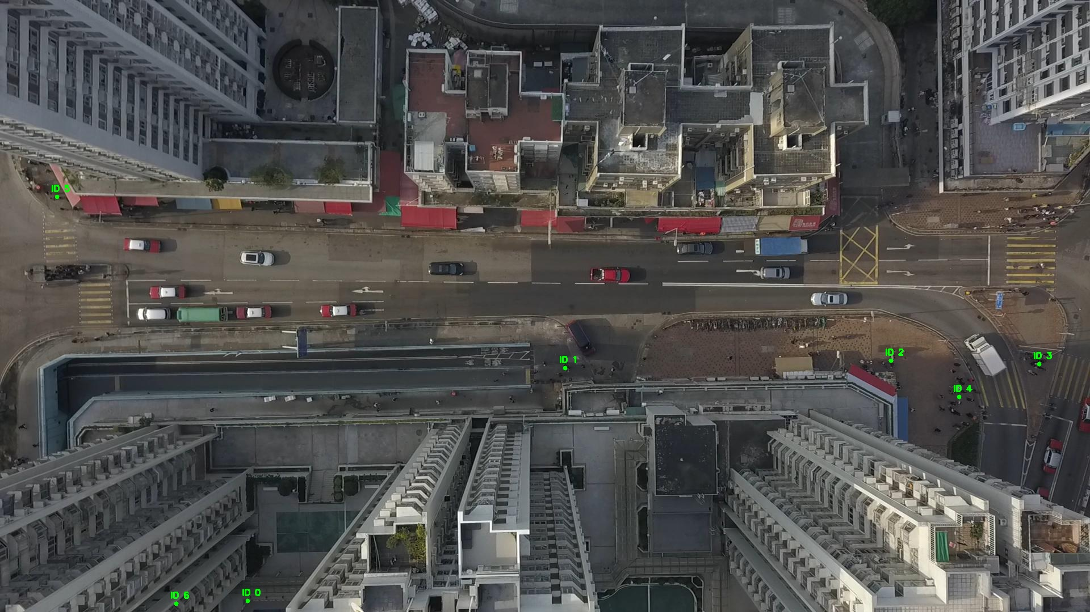

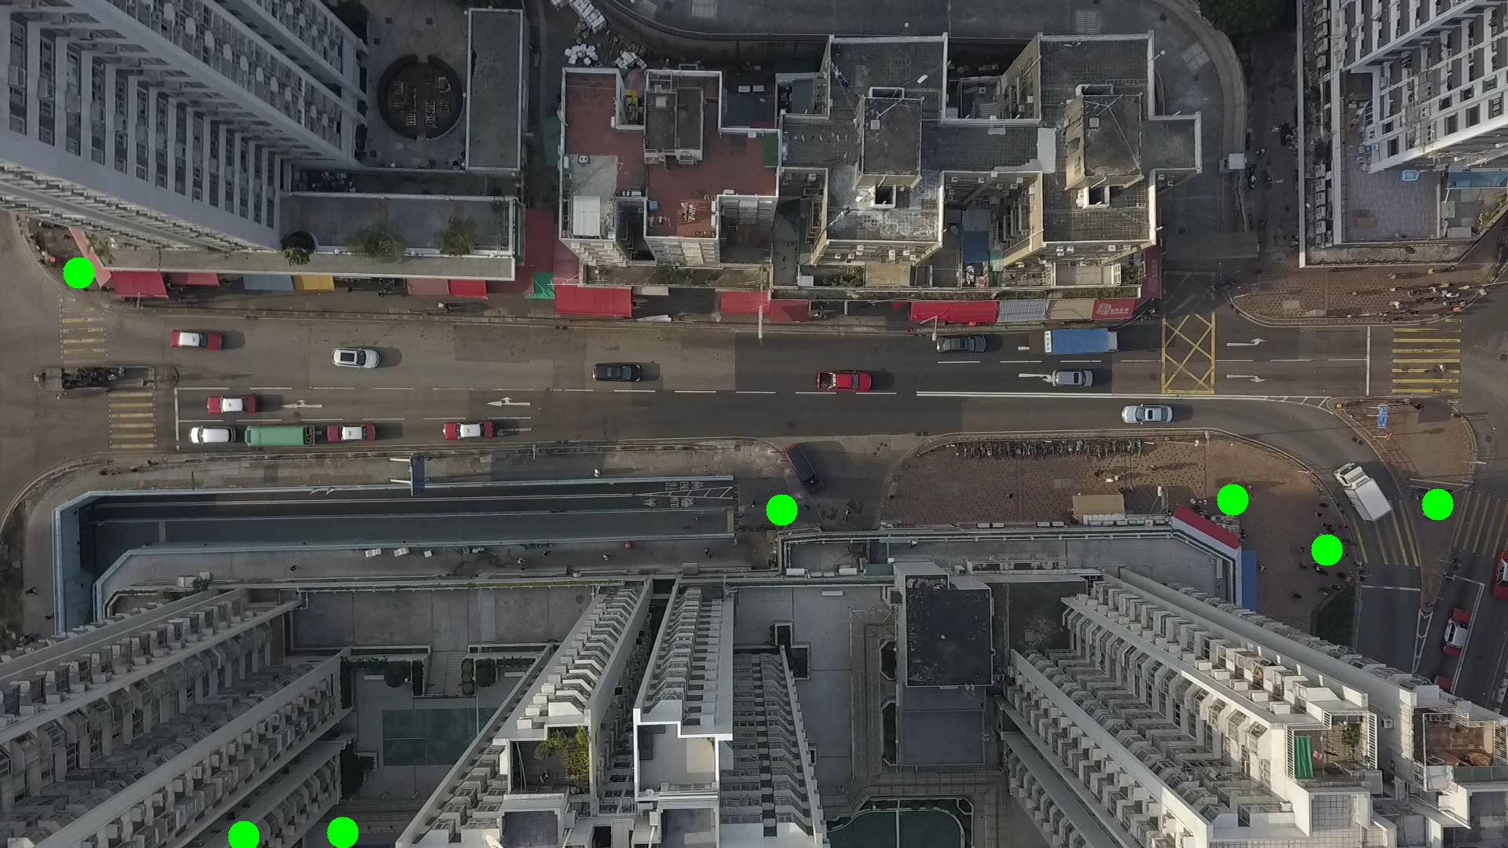

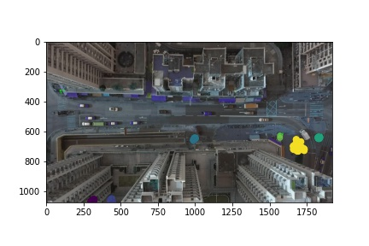

Silhouette metric for img016008.jpg is: 0.7793744522839045

Davies Bouldin metric for img016008.jpg is: 0.15622111306532505

Calinski Harabasz metric for img016008.jpg is: 210552.50264241782

ID 0: (447, 1073)

ID 1: (994, 650)

ID 2: (1569, 627)

ID 3: (1827, 640)

ID 4: (1693, 696)

ID 5: (100, 347)

ID 6: (304, 1069)

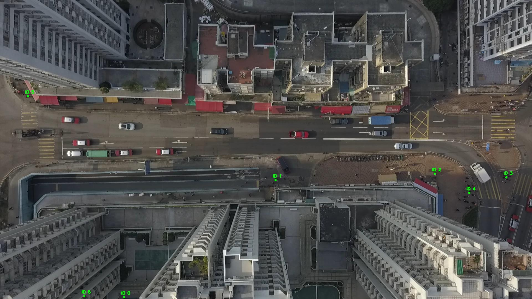

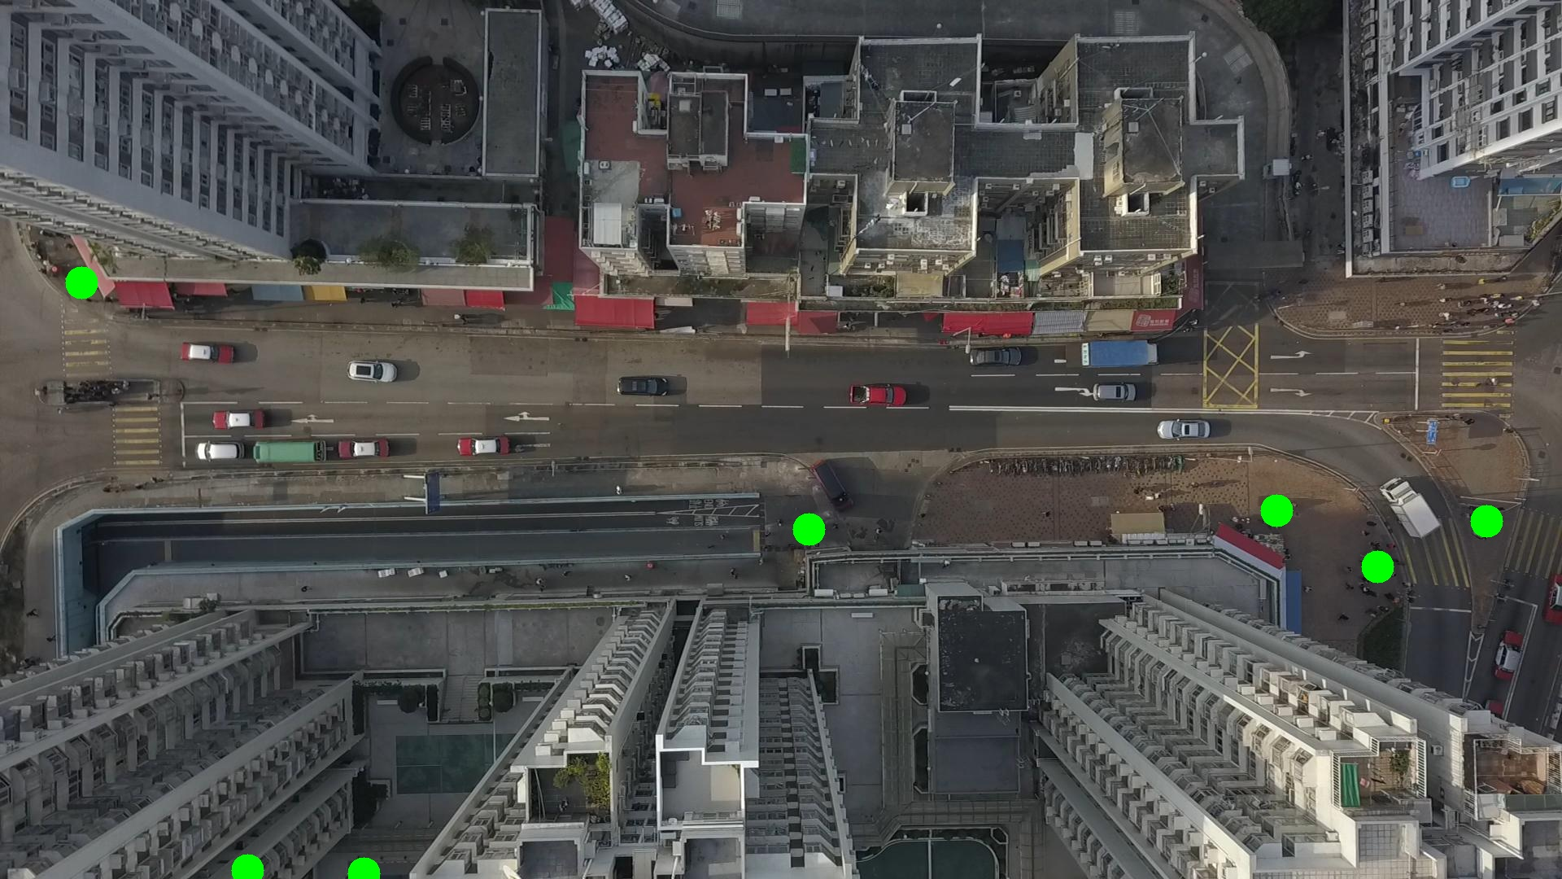

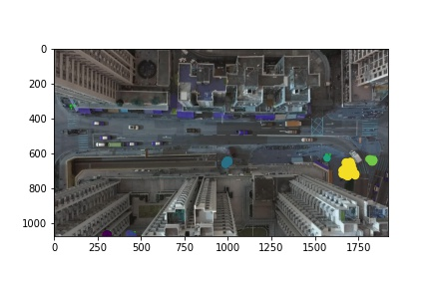

Silhouette metric for img016009.jpg is: 0.835224351354995

Davies Bouldin metric for img016009.jpg is: 0.15620847324633905

Calinski Harabasz metric for img016009.jpg is: 548985.8366982109

ID 0: (433, 1061)

ID 1: (995, 651)

ID 2: (1569, 627)

ID 3: (1826, 642)

ID 4: (1693, 696)

ID 5: (100, 347)

ID 6: (305, 1068)

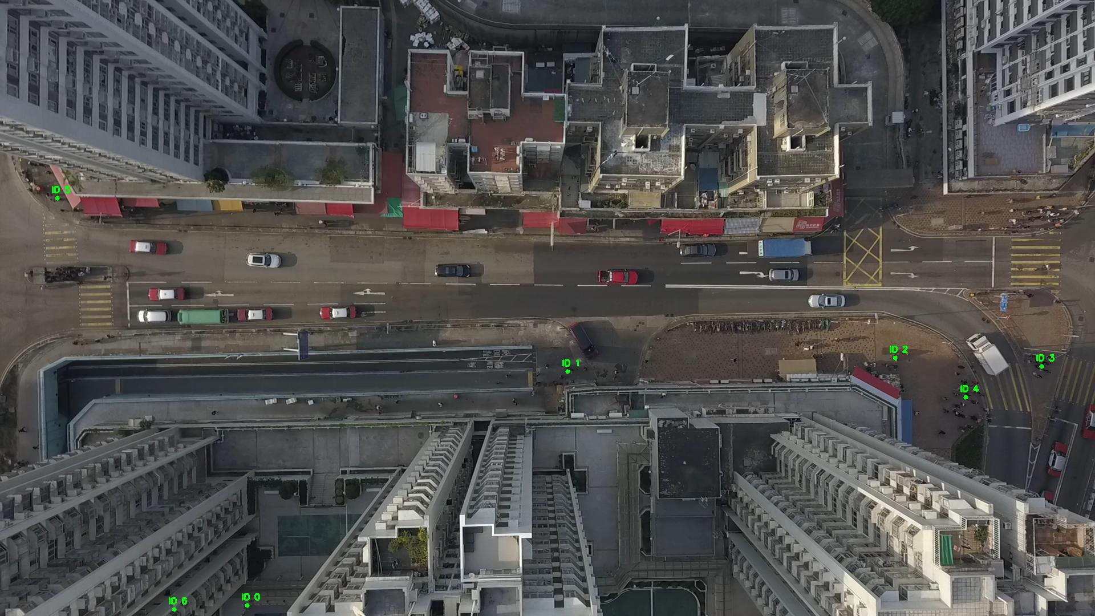

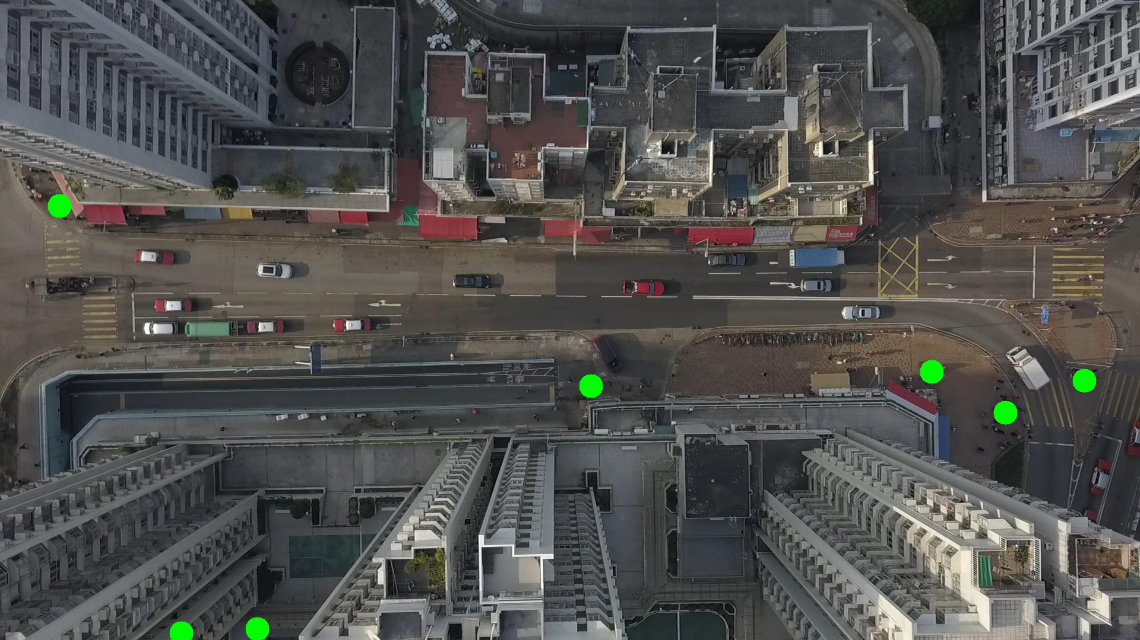

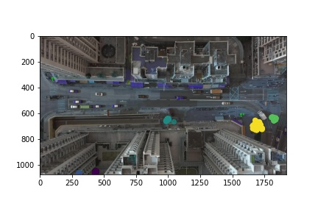

Silhouette metric for img016010.jpg is: 0.830222730289755

Davies Bouldin metric for img016010.jpg is: 0.14837428346660497

Calinski Harabasz metric for img016010.jpg is: 233725.55137040452

ID 0: (432, 1062)

ID 1: (993, 651)

ID 2: (1569, 627)

ID 3: (1824, 640)

ID 4: (1694, 694)

ID 5: (100, 347)

ID 6: (305, 1068)

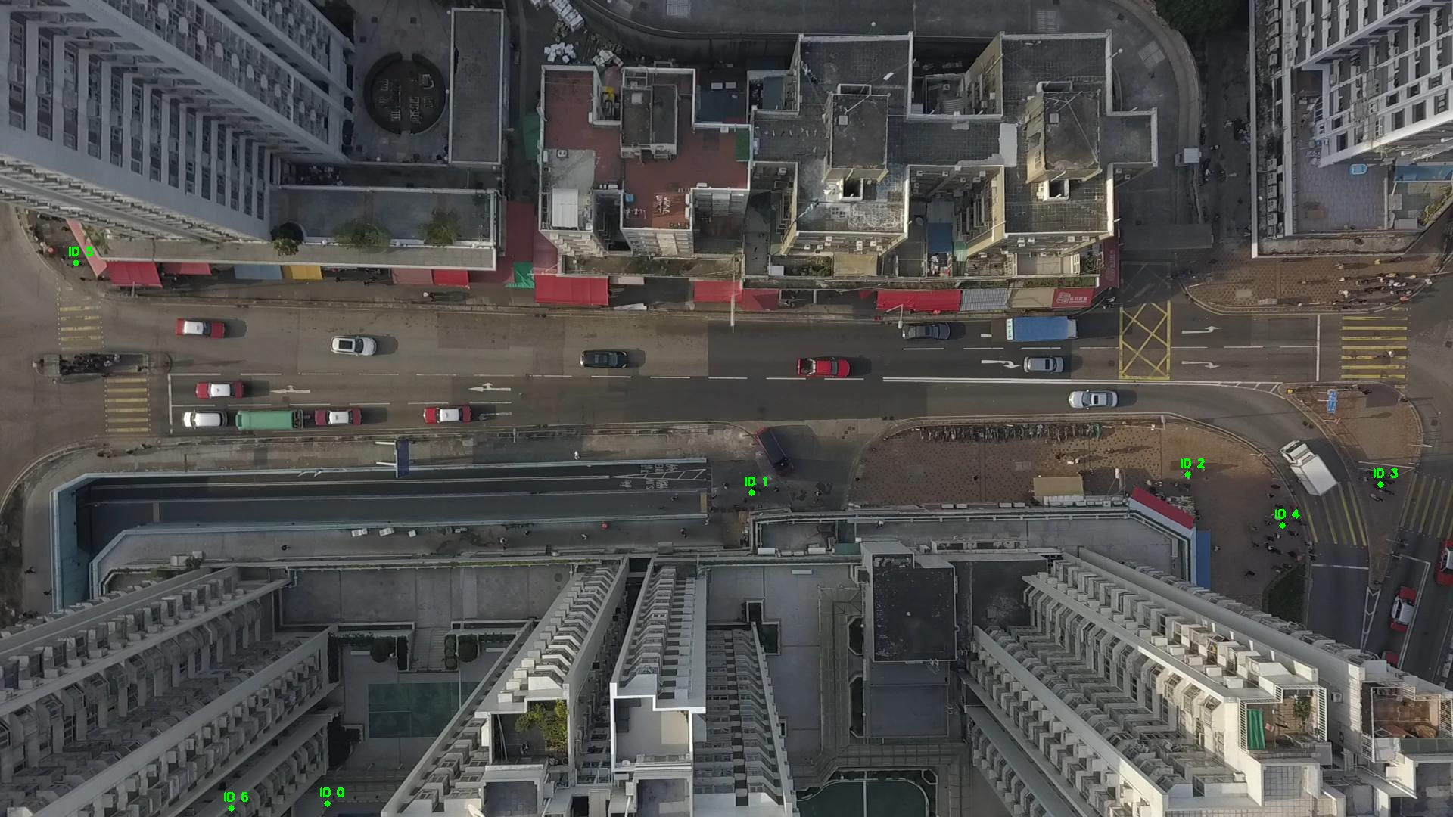

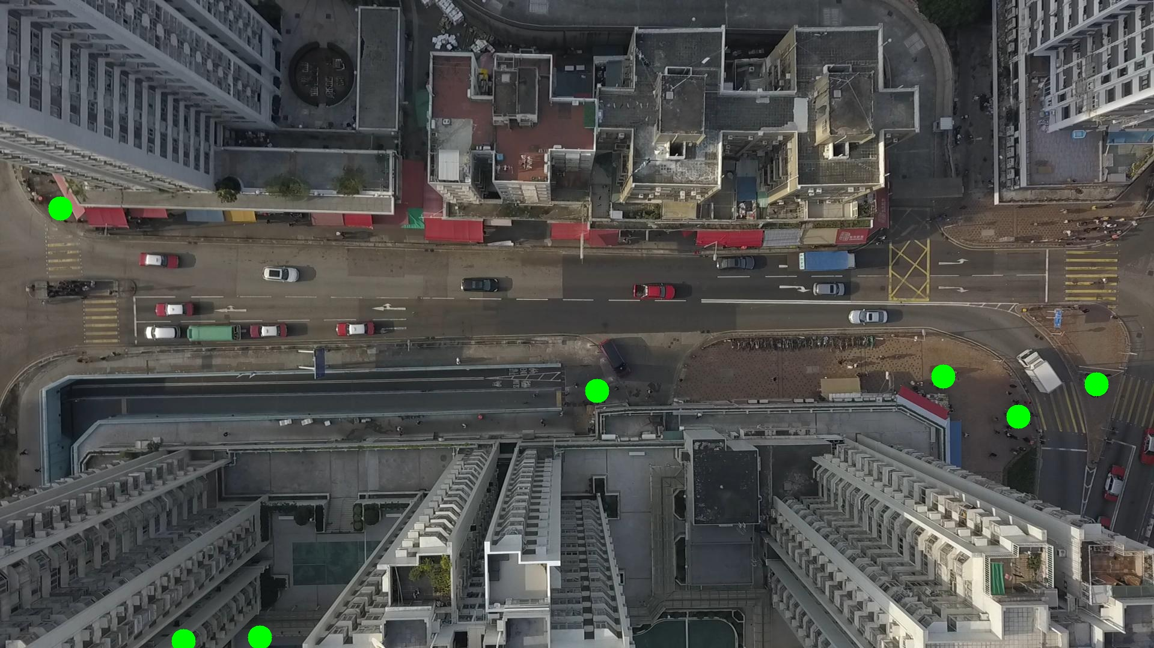

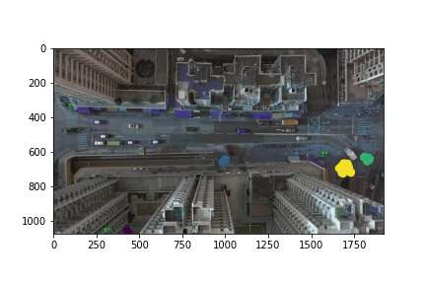

Silhouette metric for img016011.jpg is: 0.8538853773204443

Davies Bouldin metric for img016011.jpg is: 0.140750095538129

Calinski Harabasz metric for img016011.jpg is: 465354.60137918126

ID 0: (434, 1059)

ID 1: (997, 649)

ID 2: (1569, 627)

ID 3: (1826, 640)

ID 4: (1691, 688)

ID 5: (100, 347)

ID 6: (308, 1066)

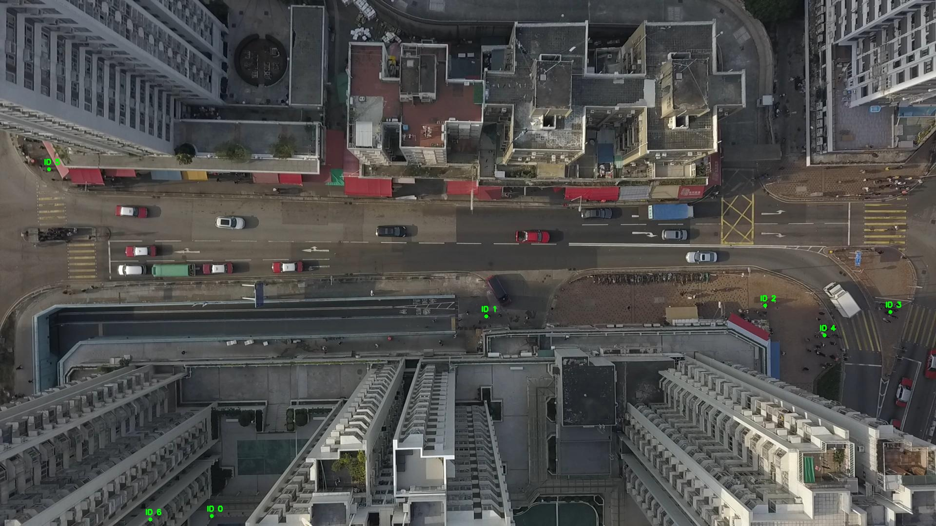

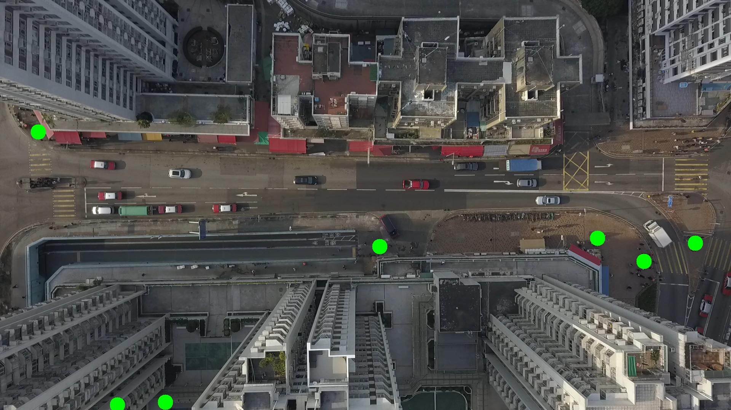

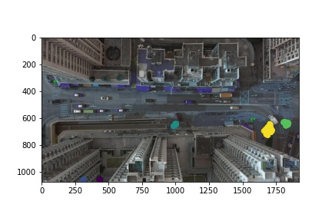

Silhouette metric for img016012.jpg is: 0.8264906794064579

Davies Bouldin metric for img016012.jpg is: 0.14871455655752003

Calinski Harabasz metric for img016012.jpg is: 216136.4917618071

ID 0: (436, 1058)

ID 1: (993, 652)

ID 2: (1569, 627)

ID 3: (1826, 641)

ID 4: (1692, 697)

ID 5: (100, 347)

ID 6: (310, 1065)

